TOURBILLON SKELET CERAMIC - SKULL PINK POINTILLISM:
DEATH NEVER LOOKED SO GOOD...
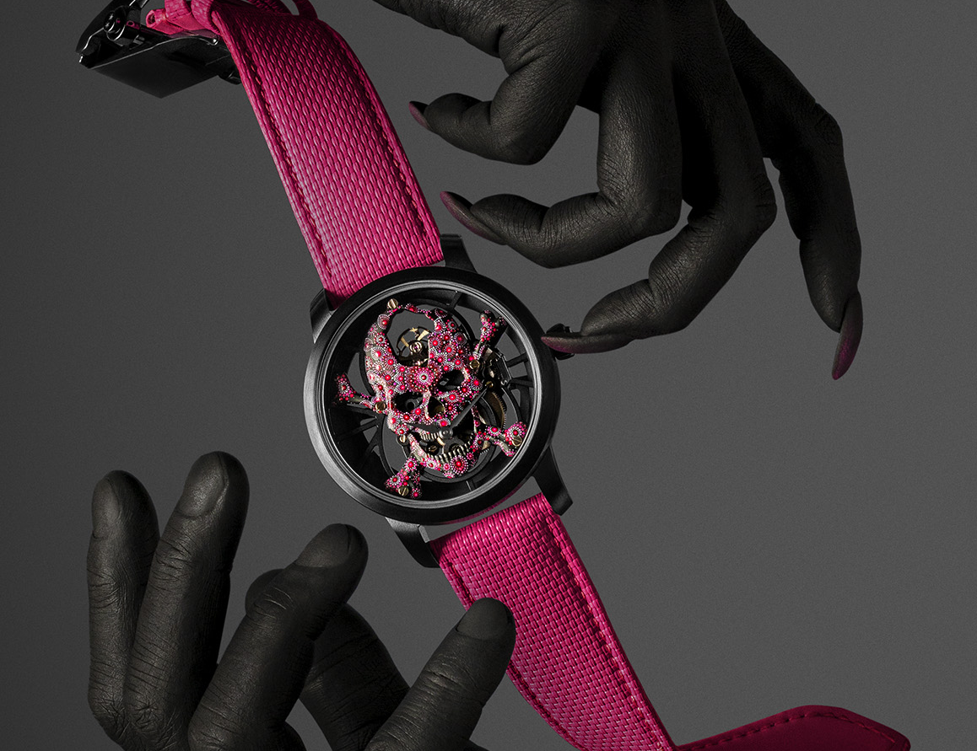
Rarely has a Tourbillon Skull gone to such lengths. Chic yet punk, perfectly controlled yet completely untamed... A skilful combination of extremes, executed by the master Artisans at Jaquet Droz. A unique piece crafted by hand in a bold pink set in an intense black ceramic case, it offers a vision of time suspended between life and death; a carpe diem encapsulated in a watch as audacious as it is elusive.

There will only ever be one piece, as it was born from the imagination of a single collector. Jaquet Droz brought this vision to life. The Tourbillon Skull Pink Pointillism is a meeting of minds. On the one side, a lover of fine watchmaking who has pushed the boundaries of tradition to create their own. On the other, a master watchmaker with expertise in this tradition dating back over 250 years, today offering a vision of Disruptive Legacy that straddles the centuries and the arts to produce unique pieces of great beauty.
At the heart of the piece lies the Jaquet Droz Tourbillon Skull movement, an original creation that is a skeletonised, atomised version of the famous figure-of-eight design. At the top is the tourbillon, mirroring the off-centred hours and minutes at 6 o'clock. Over the suspended skeleton architecture, a hand-sculpted and hand-painted 18-karat gold skull offers an unnerving interpretation of tempus fugit. The piece conveys the passage of time with the skull, the classic element of still life, combining it with the brightest and happiest of colours, a bold, striking pink.
What truly makes it stand out is a technique dear to the Jaquet Droz Artisans: pointillism. Almost all of the skull is covered with dots of paint – more than 3000 in total – individually applied by hand with brushes, some of which have only a single bristle. The shades of pink enhance the geometry of the calibre, a modern, structured design which highlights both the material and the movement, and the spaces between. With perfect harmony, this composition is set inside a ceramic case of an uncompromising and intense black, which reinforces the contrast with the pink of the skull and the textured rubber strap that accompanies it.
Studio 8 at Jaquet Droz was instrumental in allowing the collector and artisans to share a vision. This hub of cutting-edge technology in La Chaux-de-Fonds allows remote customers to be virtually present at each stage of the creation of their timepiece. From the brief to the 3D model, and for the validation of all the technical and aesthetic choices, Studio 8, with its integrated 4K cameras allowing digital immersion into the heart of the watch, allows the wildest of dreams to become reality. The Skull Pink Pointillism is no exception. The spirit gave rise to the method, the material dictated how it was used. Within the equally masculine and feminine 42-mm case beats the Jaquet Droz flying tourbillon self-winding movement with a power reserve of eight days. The screws and finishes are all custom-made, including the unique engraving on the oscillating weight. Once again, Jaquet Droz has been able to capture the imagination and personal preferences of a collector to manufacture an exceptional and unique custom piece which truly reflects them.
“Create your own. As unique as you are”

